**DAILY ONLINE ACTIVITIES SUMMARY**

|  |  |  |  |  |  |  |  |  |
| --- | --- | --- | --- | --- | --- | --- | --- | --- |
| **Date:** | 21/05/2020 | | | | | **Name:** | CHANDANA S | |
| **Sem & Sec** | 4TH&A | | | | | **USN:** | 4AL18CS016 | |
| **Online Test Summary** | | | | | | | | |
| **Subject** | | Microcontroller and Embedded Systems(18CS44) | | | | | | |
| **Max. Marks** | | 30 | | **Score** | | | 19 | |
| **Certification Course Summary** | | | | | | | | |
| **Course** | Introduction to Programming | | | | | | | |
| **Certificate Provider** | | | Great Learning | | **Duration** | | | 2.5 Hours |
| **Coding Challenges** | | | | | | | | |
| **Problem Statement:** 1. Write a C or Java program to implement FCFS and SJF process scheduling.  Input: Processes with burst time  Output: Process being scheduled | | | | | | | | |
| **Status:** Completed | | | | | | | | |
| **Uploaded the report in Github** | | | | | YES | | | |
| **If yes Repository name** | | | | | <https://github.com/chandushivalingareddy/lockdown-coding> | | | |
| **Uploaded the report in slack** | | | | | YES | | | |

**Online Test Details:**

The online test was from module 1 which was about Arm Embedded Systems and Arm Processor Fundamentals. There were 30 questions of 1 mark each which lasted for 40 minutes. The questions were easy. I scored 19 out of 30.

**Snapshot**:

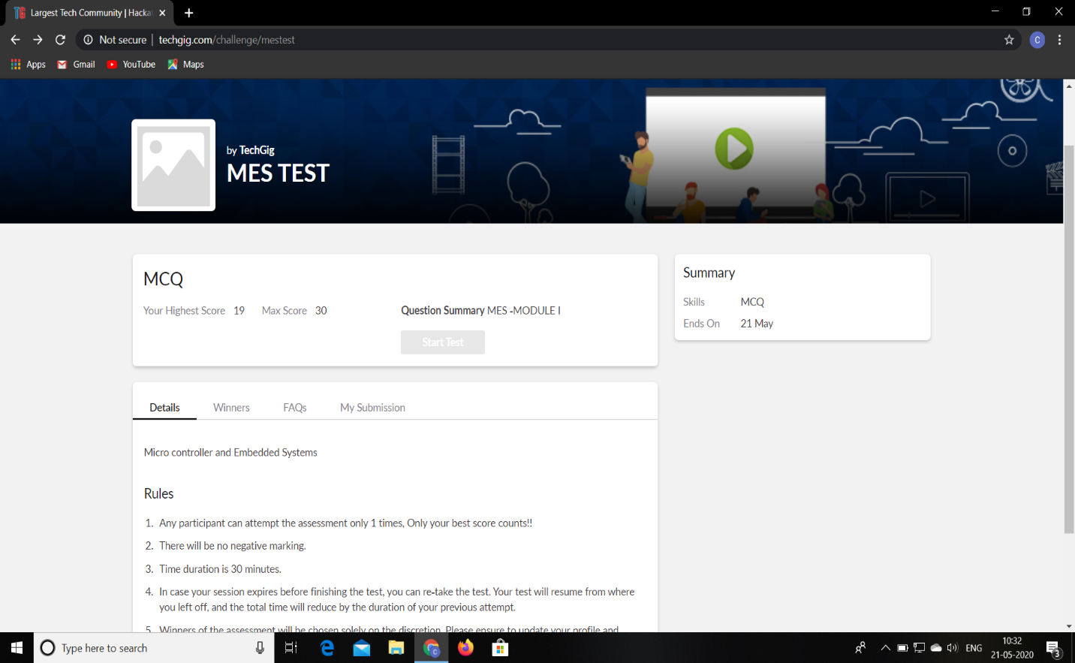

**Certification Course Details:**

**Name of the course**: Introduction to Programming

**Certificate Provider**: Great Learning

This course has 3 sections and the total duration is 5.5 hours.

Today I went through the first section of the course and learnt the Introduction to Python and Python Basics. I have gone through the Looping Statements,Functions,Operators in Python and List in Python, Dictionary in Python and Python Tuples.

**Snapshot:**

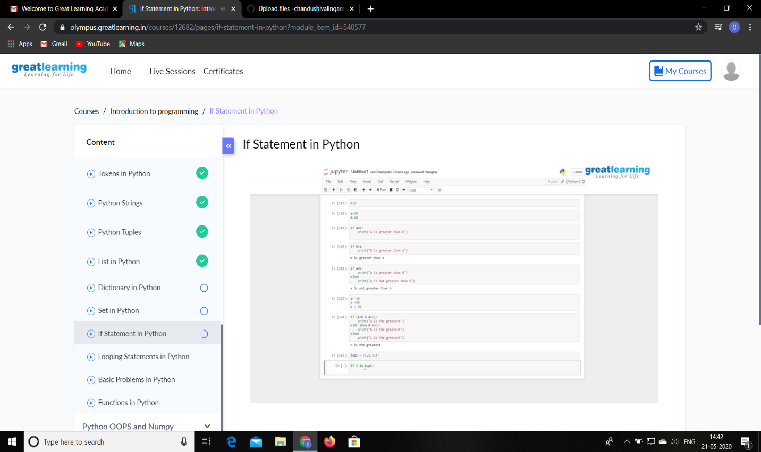

**Online Coding Details:**

Problem 1:

Output: Process being scheduled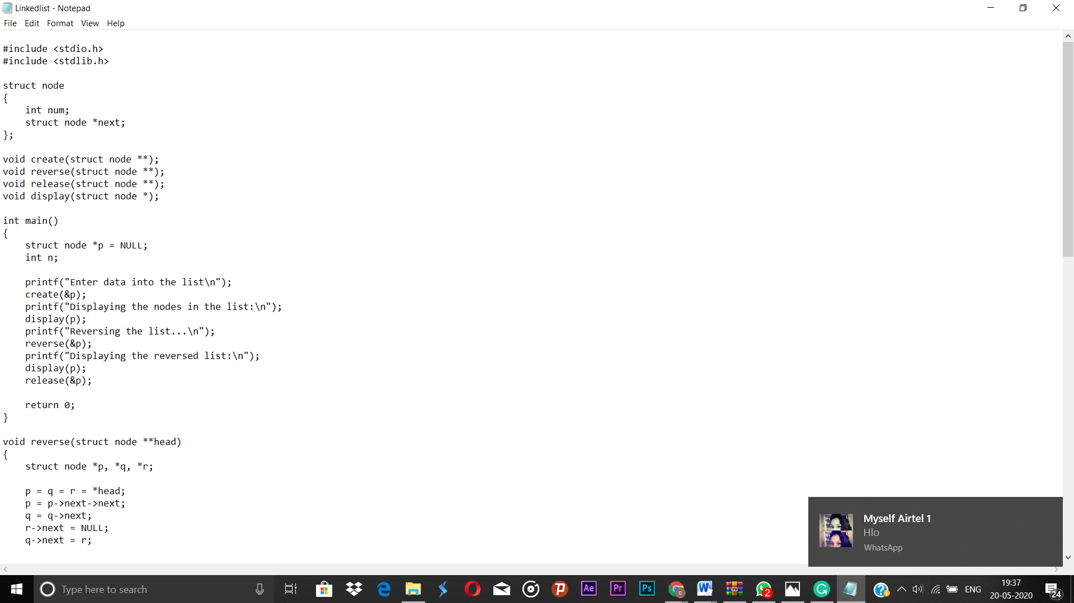Top of Form

Bottom of Form

Write a C or Java program to implement FCFS and SJF process scheduling.

Input: Processes with burst time

Output: Process being scheduled

**Snapshot:**

